In view of the following facts - status of receipts whether as Karta of their respective HUF or Individual ?

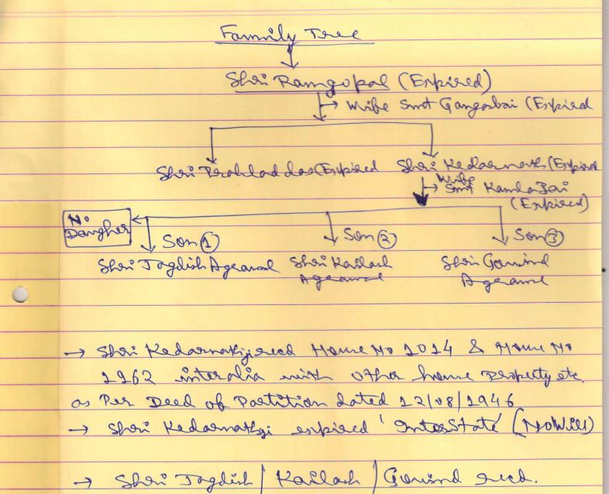
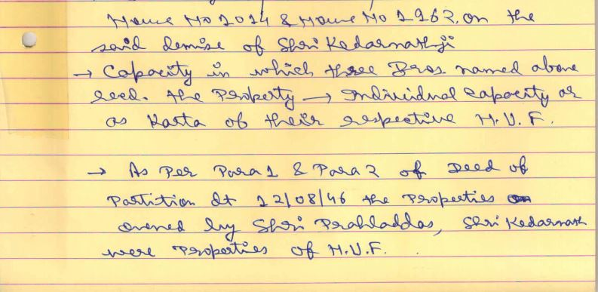
PARA 1 AND PARA 2 OF PARTITION DEED DT. 12/08/16
…And the movable and immovable properties mentioned in the first, second , third schedules hereto is the joint property of the said family , part of it being the ancestral property and part having been acquired by the family with joint funds or earnings of individual members thrown into the common stock…

