***FOREIGN REMITTANCES & TCS PROVISIONS UNDER UNION BUDGET 2025***

*Dear Friends,*

*Hon’ble Finance Minister has presented excellent and people-oriented Budget-2025 on 1st February 2025. There are many expectations of the people from this Budget and PM as well as FM has assured earlier that they are going to gift various benefits to the people and the industry in this Budget-2025.*

*The FM has herd voices of middle class, which is the most exploited taxpayers of India. In this Budget-2025 the personal taxation limit has been increased from Rs. 7 lakhs to Rs. 12 lakhs. It means that if you are earning income up to Rs. 12 Lakhs or less, then you are not going to pay any tax. This has removed at least 1 Crore people from taxation net and provides more money in the hands of middle class. This will lead to an increase in their purchasing power and an increase in turnover of FMCG companies.*

*The Government has also done a lot in front of Foreign Remittances, the rate of TCS has been reduced and the TCS applicable threshold has been increased from Rs. 7 lakhs to Rs. 10 Lakhs. One of the most important decisions of NIL, TCS on remittances to abroad in case education loan has been taken to fulfill foreign education. It means that a student going abroad for education and his/her education is sponsored by way of education loan by his/her parents, then no TCS will be applicable on this foreign remittance.*

*In this article we are going to discuss TCS Rules related to prior and post Union Budget 2025.*

***What is TCS on Foreign Remittance***

*Tax Collected at Source (TCS) on foreign remittances is a specific percentage collected on outward remittances made under the Liberalised Remittance Scheme. The amount collected as TCS on a particular transfer is deposited with the Income Tax Department and documented on your Form 26AS.*

*TCS stands for Tax Collected at Source. TCS is not a fee but a tax withholding that can be claimed when filing tax returns.*[*Sec 206C 1(G) of the Income Tax Act 1961*](https://incometaxindia.gov.in/Pages/section-wise-statutes.aspx)*deals with TCS tax on foreign remittances.*

|  |
| --- |
| ***SECTION (1G) -TCS PROVISIONS ON FOREIGN REMITTANCES-*** *Every person,—*[*(a)*](https://indiankanoon.org/doc/60519501/)*being an authorised dealer, who receives an amount, for remittance out of India from a buyer, being a person remitting such amount out of India under the Liberalised Remittance Scheme of the Reserve Bank of India;*  [*(b)*](https://indiankanoon.org/doc/140224454/)*being a seller of an overseas tour program package, who receives any amount from a buyer, being the person who purchases such package, shall, at the time of debiting the amount payable by the buyer or at the time of receipt of such amount from the said buyer, by any mode, whichever is earlier, collect from the buyer, a sum equal to five per cent of such amount as income-tax:*  ***Provided that*** *the authorised dealer shall not collect the sum, if the amount or aggregate of the amounts being remitted by a buyer is less than seven lakh rupees in a financial year and is for a purpose other than purchase of overseas tour program package:*  ***Provided further that*** *the sum to be collected by an authorised dealer from the buyer shall be equal to five per cent of the amount or aggregate of the amounts in excess of seven lakh rupees remitted by the buyer in a financial year, where the amount being remitted is for a purpose other than purchase of overseas tour program package:*  ***Provided also that*** *the authorised dealer shall collect a sum equal to one half per cent of the amount or aggregate of the amounts in excess of seven lakh rupees remitted by the buyer in a financial year, if the amount being remitted out is a loan obtained from any financial institution as defined in section 80E, for the purpose of pursuing any education:*  ***Provided also that*** *the authorised dealer shall not collect the sum on an amount in respect of which the sum has been collected by the seller:*  ***Provided also that*** *the provisions of this sub-section shall not apply, if the buyer is,—*  [*(i)*](https://indiankanoon.org/doc/74067509/)*liable to deduct tax at source under any other provision of this Act and has deducted such amount;*  [*(ii)*](https://indiankanoon.org/doc/20039328/)*the Central Government, a State Government, an embassy, a High Commission, a legation, a commission, a consulate, the trade representation of a foreign State, a local authority as defined in the Explanation to clause (20) of section 10 or any other person as the Central Government may, by notification in the Official Gazette, specify for this purpose, subject to such conditions as may be specified therein.*  ***Explanation****.—For the purposes of this sub-section,—*  *(i)"authorised dealer" means a person authorised by the Reserve Bank of India under sub-section (1) of section 10 of the Foreign Exchange Management Act, 1999 (42 of 1999) to deal in foreign exchange or foreign security;*  *(ii)"overseas tour programme package" means any tour package which offers visit to a country or countries or territory or territories outside India and includes expenses for travel or hotel stay or boarding or lodging or any other expenditure of similar nature or in relation thereto.* |

***TCS RATES ON FOREIGN REMITTANCES FROM INDIA-PRIOR TO BUDGET 2025***

*This table details the TCS rate for foreign remittances under LRS for different purposes, effective from October 2023 onwards:*

|  |  |
| --- | --- |
| *Outward Remittance Purpose* | *TCS Rates\** |
| *LRS for Education Loan from financial institution.* | *0.5% for any amount above INR 7,00,000.* |
| *LRS for Education Fees other than bank-financed loan.* | *5% for any amount above INR 7,00,000.* |
| *LRS for Medical Treatment purposes.* | *5% for any amount above INR 7,00,000.* |
| *LRS for other purposes.* | *20% for any amount above INR 7,00,000.* |
| *Overseas Tour Program Purchase.* | *5% for an amount up to INR 7,00,000; 20% for any amount above INR 7,00,000.* |

*\*TCS Rates as effective from 1 October 2023 onwards.*

***TCS RATES ON FOREIGN REMITTANCES FROM INDIA-POST TO BUDGET 2025***

*This table details the TCS rate for foreign remittances under LRS for different purposes, effective from 1ST April,2025 onwards:*

|  |  |
| --- | --- |
| *Outward Remittance Purpose* | *TCS Rates\** |
| *LRS for Education Loan from financial institution.* | *NIL for any amount above INR 10,00,000.* |
| *LRS for Education Fees other than bank-financed loan.* | *5% for any amount above INR 10,00,000.* |
| *LRS for Medical Treatment purposes.* | *5% for any amount above INR 10,00,000.* |
| *LRS for other purposes.* | *20% for any amount above INR 10,00,000.* |
| *Overseas Tour Program Purchase.* | *5% for an amount up to INR 10,00,000; 20% for any amount above INR 10,00,000.* |

*\*TCS Rates as effective from 1st April 2025 onwards.*

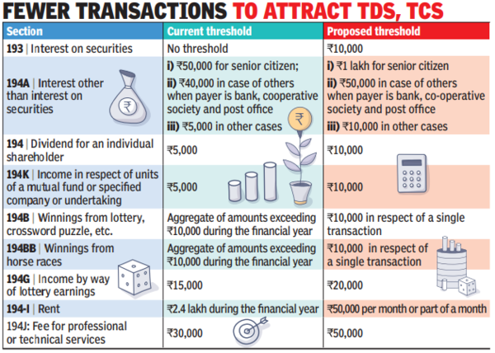

***CONCLUSION:*** *Union Budget-2025 is one of the best budgets of Modi Government till presented, it has taken care of all sectors of Indian Economy such as Education, Defense, Railway, Shipping, Banking, Infra, health care and personal finance. The reduction in rate of TDS /TCS and increase threshold limits will boost morale of people and ease way of doing business. The Budget has taken care of senior citizens also by increasing threshold limit of deduction of TDS/TCS on interest from Rs. 50,000/- to Rs. 1,00,000/-. Overall, the best Budget fulfilling expectations of all sectors of economy, especially middle class.*

***DISCLAIMER:*** *the article presented here is only for sharing information with readers. In case of necessity do consult with professionals.*